Table : Worker

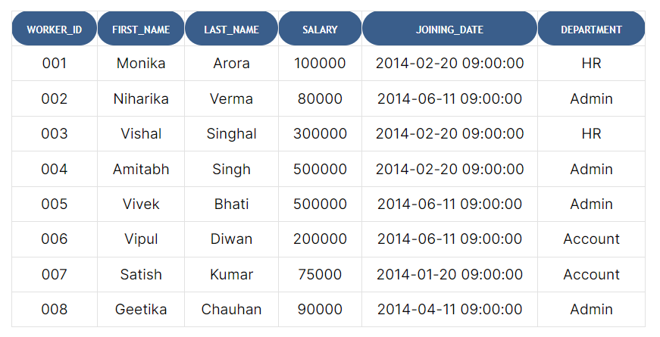

Table : Bonus

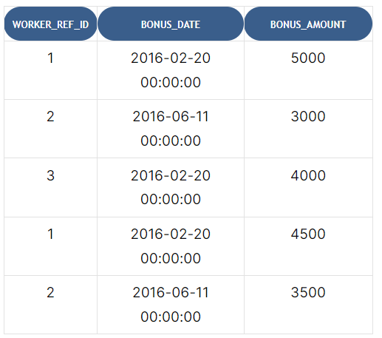

Table : Title

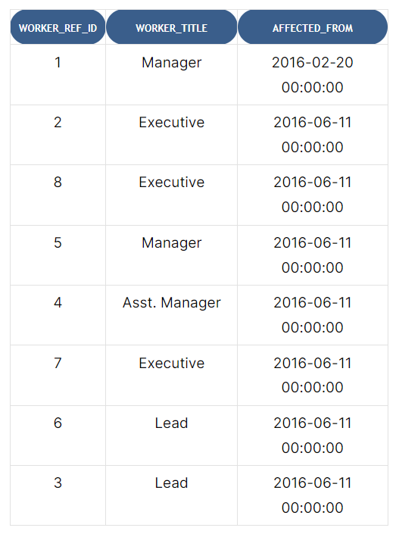

Q1. Write an SQL query to fetch “FIRST_NAME” from the Worker table using the alias name <WORKER_NAME>.

**>> Select first_name from worker as ‘WORKER_NAME’**

#### Q2. Write an SQL query to fetch unique values of DEPARTMENT from the Worker table.

**>> Select distinct department from worker**

#### Q3. Write an SQL query to print all Worker details from the Worker table order by FIRST_NAME Ascending.

#### >> Select * from worker order by FIRST_NAME asc

#### Q4. Write an SQL query to print all Worker details from the Worker table order by FIRST_NAME Ascending and DEPARTMENT Descending.

#### >> Select * from worker order by FIRST_NAME asc and DEPRTMENT desc

**Q5. Write an SQL query to print details for Workers with the first names “Vipul” and “Satish” from the Worker table**

**>> Select * from worker where FIRST_NAME in (‘Vipul, ’Satish’)**

#### Q5. Write an SQL query to print details of Workers with DEPARTMENT name as “Admin”.

#### >> Select * from worker where DEPARTMENT = ’Admin’

#### Q6. Write an SQL query to print details of the Workers whose FIRST_NAME contains ‘a’.

**>> Select * from worker where FIRST_NAME Like ’%a%’**

#### Q7. Write an SQL query to print details of the Workers whose FIRST_NAME ends with ‘h’ and contains six alphabets.

**>> Select * from worker where FIRST_NAME Like ’_____h’**

#### Q8. Write an SQL query to print details of the Workers whose SALARY lies between 100000 and 500000.

**>> Select * from worker where SALARY Between 100000 and 500000**

#### Q9. Write an SQL query to fetch the count of employees working in the department ‘Admin’.

**>> Select Count(*) FROM worker where department = ‘Admin’**

#### Q10. Write an SQL query to print details of the Workers whose FIRST_NAME ends with ‘a’.

**>> Select * from worker where FIRST_NAME Like ’%a’**